

Guernsey Road Poole BH12 4LL

Online Safety Policy – (Previously E-Safety)
Version | 1.3 | Review Date | February 2022
Review Cycle | Triennially | Next Review Due | February 2025
Author / Owner | Tim Davis - ICT Coordinator

Contents
1. Aims 3
2. Legislation and guidance 3
3. Roles and responsibilities 4
4. Educating pupils about online safety 6
5. Educating parents about online safety 10
6. Cyber-bullying 11
7. Acceptable use of the internet in school 13
8. Pupils using mobile devices in school 13
9. Staff using work devices outside school 13
10. How the school will respond to issues of misuse 14
11. Training 14
12. Monitoring arrangements 15
13. Links with other policies 15
Appendix 1: Pupil acceptable use agreement (pupils and parents/carers) 16
Appendix 2: acceptable use agreement (staff, governors, volunteers and visitors) 17
Appendix 3: online safety training needs – self audit for staff 18
Appendix 4: online safety incident report log - Example from CPOMS 20
Appendix 5: online safety curriculum statement overview – Adapted from Childnet.com (ES4 additional by TD) 21
Appendix 6: SMSC Curriculum links 29
Appendix 6: Winchelsea Top 10 Online Safety tips 30
Appendix 7: online safety resources list including but not exclusive to: 31

1. Aims
Our school aims to:
- Have robust processes in place to ensure the online safety of pupils, staff, volunteers and governors
- Deliver an effective approach to online safety, which empowers us to protect and educate the whole school community in its use of technology, including mobile and smart technology (which we refer to as ‘mobile phones’)
- Establish clear mechanisms to identify, intervene and escalate an incident, where appropriate
The 4 key categories of risk
Our approach to online safety is based on addressing the following categories of risk:
- Content – being exposed to illegal, inappropriate or harmful content, such as pornography, fake news, racism, misogyny, self-harm, suicide, anti-Semitism, radicalisation and extremism
- Contact – being subjected to harmful online interaction with other users, such as peer-to-peer pressure, commercial advertising and adults posing as children or young adults with the intention to groom or exploit them for sexual, criminal, financial or other purposes
- Conduct – personal online behaviour that increases the likelihood of, or causes, harm, such as making, sending and receiving explicit images (e.g. consensual and non-consensual sharing of nudes and semi-nudes and/or pornography), sharing other explicit images and online bullying; and
- Commerce – risks such as online gambling, inappropriate advertising, phishing and/or financial scam

2. Legislation and guidance
This policy is based on the Department for Education’s (DfE) statutory safeguarding guidance, Keeping Children Safe in Education, and its advice for schools on:
- Teaching online safety in schools
- Preventing and tackling bullying and cyber-bullying: advice for headteachers and school staff
- [Relationships and sex education –
- Searching, screening and confiscation
It also refers to the DfE’s guidance on protecting children from radicalisation.
It reflects existing legislation, including but not limited to the Education Act 1996 (as amended), the Education and Inspections Act 2006 and the Equality Act 2010. In addition, it reflects the Education Act 2011, which has given teachers stronger powers to tackle cyber-bullying by, if necessary, searching for and deleting inappropriate images or files on pupils’ electronic devices where they believe there is a ‘good reason’ to do so.
.
The policy also takes into account Winchelsea Special School’s bespoke ICT Life Skill and Online Safety Curriculum developed from Childnet’s ICT and online safety curriculum resources.

3. Roles and responsibilities
3.1 The governing board
The governing board has overall responsibility for monitoring this policy and holding the headteacher to account for its implementation.
The governing board will co-ordinate regular meetings with appropriate staff to discuss online safety, and monitor online safety logs as provided by the designated safeguarding lead (DSL) Adam Bradford. The governor who oversees online safety is Mrs S Fallon within her role as Safeguarding Governor .
All governors will:
- Ensure that they have read and understand this policy
- Agree and adhere to the terms on acceptable use of the school’s ICT systems and the internet (appendix 3)
- Ensure that, where necessary, teaching about safeguarding, including online safety, is adapted for vulnerable children, victims of abuse and some pupils with SEND because of the importance of recognising that a ‘one size fits all’ approach may not be appropriate for all children in all situations, and a more personalised or contextualised approach may often be more suitable
3.2 The headteacher
The headteacher (Geoff Cherrill) is responsible for ensuring that staff understand this policy, and that it is being implemented consistently throughout the school.
3.3 The designated safeguarding lead and Online Safety Champion
Details of the school’s DSL and his team are set out in our safeguarding policy as well as relevant job descriptions.
The DSL takes lead responsibility for online safety in school, in particular:
- Supporting the headteacher in ensuring that staff understand this policy and that it is being implemented consistently throughout the school
- Working with the headteacher, IT Systems Manager and other staff, as necessary, to address any online safety issues or incidents
- Managing all online safety issues and incidents in line with the school child protection policy
- Ensuring that any online safety incidents are logged through the schools safeguarding and reporting system, Child Protection Online Management System (CPOMS) are dealt with appropriately in line with this policy
- Ensuring that any incidents of cyber-bullying are logged and dealt with appropriately in line with the school behaviour policy
- Providing regular reports on online safety in school to the headteacher and/or governing board
The Online Safety Champion (Tim Davis) takes lead responsibility for online safety in school, in particular:
- Updatign and monitoring on the Online Safety Curriculum
- Updating and delivering staff training on online safety (appendix 4 contains a self-audit for staff on online safety training needs)
- Liaising with other agencies and/or external services if necessary
This list is not intended to be exhaustive.
3.4 The IT Systems Manager
The ICT manager is responsible for:
- Putting in place an appropriate level of security protection procedures, such as filtering and monitoring systems, which are reviewed and updated annually to assess effectiveness and ensure pupils are kept safe from potentially harmful and inappropriate content and contact online while at school, including terrorist and extremist material
- Ensuring that the school’s ICT systems are secure and protected against viruses and malware, and that such safety mechanisms are updated regularly
- The school has an online filtering system for online activity. Inappropriate content and searches are blocked. The ICT manager reserves the right to search for specific conflicts when requested.
- Blocking access to potentially dangerous sites and, where possible, preventing the downloading of potentially dangerous files
- Ensuring that any online safety incidents are logged (see appendix 5) and dealt with appropriately in line with this policy
- Ensuring that any incidents of cyber-bullying are dealt with appropriately in line with the school behaviour policy
This list is not intended to be exhaustive.
3.5 All staff and volunteers
All staff, including contractors and agency staff, and volunteers are responsible for:
- Maintaining an understanding of this policy
- Implementing this policy consistently
- Agreeing and adhering to the terms on acceptable use of the school’s ICT systems and the internet (appendix 2), and ensuring that pupils follow the school’s terms on acceptable use (appendix 1)
- The DSL to ensure that all new starters to Winchelsea School receive training and a login to report any online safety incidents through Winchelsea School’s online safeguarding reporting tool, CPOMS.
- Working with the DSL to ensure that any online safety incidents are logged through CPOMS and dealt with appropriately in line with this policy.
- Ensuring that any incidents of cyber-bullying are dealt with appropriately in line with the school behaviour policy
- Responding appropriately to all reports and concerns about sexual violence and/or harassment, both online and offline and maintaining an attitude of ‘it could happen here’
This list is not intended to be exhaustive.
3.6 Parents
Parents are expected to:
- Notify a member of staff or the headteacher of any concerns or queries regarding this policy
- Ensure their child has read, understood and agreed to the terms on acceptable use of the school’s ICT systems and internet. Where accessible and tha school will monitor and support children in this use in line with their SEN diagnosis (appendix 1)
Parents can seek further guidance on keeping children safe online from the following organisations and websites:
- What are the issues? – UK Safer Internet Centre / vodafone.co.uk/mobile/digital-parenting
- Hot topics – Childnet International
- Parent resource sheet – Childnet International
- Healthy relationships – Disrespect Nobody
3.7 Visitors and members of the community
Visitors and members of the community who use the school’s ICT systems or internet will be made aware of this policy, when relevant, and expected to read and follow it. If appropriate, they will be expected to agree to the terms on acceptable use (appendix 1).

4. Educating pupils about online safety
Teaching about online safety has been adapted for our vulnerable children from Childnet international. Pupils will be taught about online safety as part of the Winchelsea ICT Curriculum alongside RSE taken from the guidance on relationships education, relationships and sex education (RSE) and health education. The Winchelsea ICT Curriculum is in line with statuary and non statutory guidance the from Keeping Childrne safe in Education 2021 https://assets.publishing.service.gov.uk/government/uploads/system/uploads/attachment_data/file/1021914/KCSIE_2021_September_guidance.pdf
4.1 Statutory and Non Statutory Guidance and Safeguarding linked to ICT and Online Safety
‘Keeping Children Safe in Education’ - (KCSIE) Statutory Guidance for School and Colleges - Sept 2021 (Extracts)
Annex A
All Staff should:
Receive appropriate safeguarding and child protection training (including online safety) which is regularly updated.

Safeguarding Issues Linked with Online Safety

Issues that can put children at risk of harm. Behaviours linked serious violence (including that linked to county lines), radicalisation and consensual and non-consensual sharing of nude and semi-nude images and/or videos (also known as youth produced sexual imagery -YPSI) put children in danger.

Child on Child Abuse
All staff should be aware that children can abuse other children (often referred to as peer on peer abuse). It can happen both inside and outside of school/college and online. It is important that all staff recognise the indicators and signs of peer on peer abuse and know how to identify it and respond to reports.

Annex B contains important additional information about specific forms of abuse and safeguarding issues. School and college leaders and those staff who work directly with children should read this annex.
Here are the specific areas linked to internet safety to be aware of
- Child Criminal Exploitation (CCE) and Child Sexual Exploitation (CSE)
- County lines
- Modern Slavery and the National Referral Mechanism
- Cybercrime
- So-called ‘honour-based’ abuse (including Female Genital Mutilation and Forced Marriage)
- Preventing radicalisation
- The Prevent duty - Channel
- Peer on peer/ child on child abuse
- Sexual violence and sexual harassment between children in schools and colleges

4.2 Non-Statutory Guidance and Safeguarding linked to ICT and Online Safety
Government Response to the - Internet Safety Strategy Green Paper
The Government wants to help all schools to deliver a high-quality education that ensures all young people are equipped to have healthy and respectful relationships in both the online and offline world, and leave school with the knowledge to prepare them for adult life.
4.3 Teaching Online Safety in School
https://assets.publishing.service.gov.uk/government/uploads/system/uploads/attachment_data/file/811796/Teaching_online_safety_in_school.pdf
Main points
- It is important to teach pupils about the underpinning knowledge and behaviours that can help pupils to navigate the online world safely and confidently regardless of the device, platform or app.
- However, schools also need an understanding of the risks that exist online so they can tailor their teaching and support to the specific needs of their pupils.
- Schools can refer to the Education for a Connected World Framework for age specific advice about the online knowledge and skills that pupils should have the opportunity to develop at different stages of their lives.
- When planning their curriculum, and how online safety fits within it, there are a number of areas we recommend schools consider, for example how to support vulnerable pupils we recommend that schools embed teaching about online safety and harms within a whole school approach.
- Creating a culture that incorporates the principles of online safety across all elements of school life.
- Proactively engaging staff, pupils and parents/carers.
- Reviewing and maintaining the online safety principles.
- Embedding the online safety principles.
- Modelling the online safety principles consistently.
Whole school approach
- Whole-school approaches are likely to make teaching more effective than lessons alone. A whole school approach is one that goes beyond teaching to include all aspects of school life, including culture, ethos, environment and partnerships with families and the community.
- We recommend that schools embed teaching about online safety and harms within a whole school approach.

Vulnerable pupils
- Any pupil can be vulnerable online, and their vulnerability can fluctuate depending on their age, developmental stage and personal circumstance. However there are some pupils, for example looked after children and those with special educational needs, who may be more susceptible to online harm or have less support from family or friends in staying safe online. Schools should consider how they tailor their offer to ensure these pupils receive the information and support they need.

4.4 Summary of Meeting Statutory Guidance
An outline of Winchelsea’s Online Safety Curriculum in relation to statutory guidance and safeguarding procedures:
- Opportunities to embed cross curriculum learning and debate with PSHE with in proposed drop days.
- Understanding and supporting Content, Conduct, Contact & Commerce
- Curriculum and Spiritual, Moral, Social and Cultural (SMSC) development links to support the embedding of Online Safety concepts
- Trusted resources and supporting partners to go to for additional resources guidance and support.
- Pupil voice in Online Safety related issues through the Pupil Passport.
- Reporting of incidents of concern raised in lessons and the safeguarding procedures.
Winchelsea recognises internet safety has strong cross curricular links to PSHE. Elements of online behaviour, relationships and consent are woven into the PSHE and Relationships and Sex Education (RSE) curriculum by the PSHE lead (Lee Riviello).
4.5 Online Safety -Curriculum
The Winchelsea Online Safety curriculum aims to provide children with the skills and knowledge to become active citizens and interact safely online in the digital world. We recognises the additional vulnerabilities of the children at Winchelsea linked to their SEN. These include access to, or the intentional or unintentional production of, inappropriate content which can be scary, misleading or developmentally scaring. Misunderstanding of appropriate online conduct and behaviour placing them at risk to a variety of forms of exploitation. This can potentially lead to lead to undesirable contact from those wishing to exploit their vulnerabilities. Additional risks to children in understanding risks such as online gambling, inappropriate advertising, phishing and/or financial scam commerce.

It is important to dispel the myth that online and offline lives are different but in fact intertwine as one and the same thing where behaviours online and offline should mirror each other. To support the consolidation, Online Safety is not solely found in discrete lessons but has cross curricular links predominantly with PSHE and can also be found within SMSC links (Appendix 6)

4.5.1 Explorers, Seekers and Discoverers Online Safety
Evidence from a survey of parents disseminated by the SWGfL in the ‘Online Safety Update 2021’ – (attended by Tim Davis – Online Safety Champion) highlighted that one of the main concerns of parents of children with SEN who don’t fully understand the concept of being online is to keep them safe by limiting the chances of online risks though filtering and monitoring.

Children in the Discoverers strand have access to the internet to support educational games and apps on the iPads. To support them to stay safe there are filters and monitoring in place on the devices and the capacity to contain the children in specific apps using the iPads guided access feature. When ready they can be introduced to the early concept of consent by asking if it is ok to take a picture of a friend before doing so.

4.5.2 Enquirer, Key Stage 4 and Post 16 Online Safety
Although filtering and monitoring is in place across Winchelsea, the Enquirer pathway of the school who have the cognitive function to understand and potentially access the internet freely and home or at school are at the greatest risk and discrete teaching of internet safety skills is critical to keeping them safe. At Winchelsea the Online Safety curriculum was adapted, to meet the needs of the children, from the ‘www.childnet.com’ Key Stage (KS) resources from KS1 – KS3. The content of the curriculum follows three progressive subsections. (Appendix 1). New pupils can be base lined using the bespoke Online Safety assessment booklets to determine the best pitch for each child. These booklets come with a teacher assessment book containing the expected response to achieve a successful answer.

In addition to the curriculum, Winchelsea have adopted and rephrased a child net resource ‘Let’s Talk about Life Online’ as our top 10 tips.
4.6 Digital Passport
In January 2022 Winchelsea introduced a Digital Passport for the Enquirer pathway of the school adapted from ‘internetmatters.com’. The passport can be updated by children at any time and the most recent is kept in their ICT files in class. The passport covers every child’s personal view, knowledge skills and wishes for their personal life online. The purpose of the Digital Passport is to be used as an Assessment for Learning (AfL) tool for class teachers at the start of the discrete Online Safety to tailor delivery of Online Safety to meet the needs of their class or individual pupils. For example if a child was working in Online Safety 1. but highlights a vulnerability to sharing images then the teacher can adapt their planning or implement specific support with the assistance of the Online Safety Champion and or DSL. When vulnerability form Digital passport arise staff should:

- Record the vulnerability through the school safeguarding reporting system CPOMS. Then take appropriate actions for the safety of the child and inform the parent / carer of the issues that arose.
- Decide on if the child requires some 1:1 tuition on the topic or if it is beneficial to the whole class.
- Deliver the content to support the child/children in the class seeking any advice required from with the subject lead and Online Safety

5. Educating parents about online safety
Winchelsea School will raise parents’ awareness of internet safety through the school termly newsletter and other communications home, and in information via our website. This policy will also be shared with parents on the school website containing
- Links for support and reporting of internet safety concerns.
- User guide to support social media use
- Links to the latest apps, movies and games through ‘net aware’ and ‘common sense media’.
- Addition internet safety advice from SWGfL
Online safety will also be covered during parents’ evenings.
Within online safety week https://www.saferinternetday.org/ additional resources are sent home through the School contact service ‘Schoolzine’

Prior to Covid we started an annual online safety coffee morning in conjunction with Dorsets Safer School Community Team which we will reintroduce in 2022/23.

If parents have any queries or concerns in relation to online safety, these should be raised in the first instance with the headteacher and/or the DSL.
Concerns or queries about this policy can be raised with any member of staff or the headteacher.

6. Cyber-bullying
6.1 Definition
Cyber-bullying takes place online, such as through social networking sites, messaging apps or gaming sites. Like other forms of bullying, it is the repetitive, intentional harming of one person or group by another person or group, where the relationship involves an imbalance of power. (See also the school behaviour policy.)
6.2 Preventing and addressing cyber-bullying

Reporting of safeguarding concerns, including cyber bullying, to the DSL is done through CPOMS staff use tags to categories incidents within school. The Online Safety Champion (Tim Davis) receives all incidents labelled as ‘E- Safety concerns’. These incidents are predominantly dealt with by the school participation team (Adam Bradford – Lead) with advice from the Online Safety Champion or other services such as the Multi Agency Safeguarding Hub (MASH), Dorset Safer School Community Team (SSCT) where required in line with the schools safeguarding policy, anti-bullying policy, peer on peer/ child on child abuse flow chart.

Staff also receive annual internet safety training led or implemented by the ICT lead (Tim Davis) supported by the Dorset Safer Schools Community Team (SSCT). Follow up training for absentees and Online Safety relevant information in circulated via email and weekly whole school briefings where appropriate.

To help prevent cyber-bullying, we will support pupils to understand what it is and what to do if they become aware of it happening to them or others. We will ensure that pupils know how they can report any incidents and are encouraged to do so, including where they are a witness rather than the victim.

The school will actively discuss cyber-bullying with pupils, explaining the reasons why it occurs, the forms it may take and what the consequences can be. The Enquirers pathway of school will discuss cyber-bullying with their classes when there are at the level they can understand the concept, beginning with Conduct in Online safety unit 1 of the curriculum.
Teaching staff are also encouraged to find opportunities to use aspects of the curriculum to cover cyber-bullying. This includes personal, social, health and economic (PSHE) education, and other subjects where appropriate.
All staff, governors and volunteers (where appropriate) receive training on cyber-bullying, its impact and ways to support pupils, as part of safeguarding training
The school also sends information/leaflets on cyber-bullying to parents so that they are aware of the signs, how to report it and how they can support children who may be affected.
In relation to a specific incident of cyber-bullying, the school will follow the processes set out in the school behaviour policy. Where illegal, inappropriate or harmful material has been spread among pupils, the school will use all reasonable endeavours to ensure the incident is contained.
6.3 Examining electronic devices
School staff have the specific power under the Education and Inspections Act 2006 (which has been increased by the Education Act 2011) to search for and, if necessary, delete inappropriate images or files on pupils’ electronic devices, including mobile phones, iPads and other tablet devices, where they believe there is a ‘good reason’ to do so.
A good reasons linked to online safety includes information or images linked an offence that has been or is being committed, for example:
- Pornographic images
- Grooming
- Youth Produced Sexual Imagery (YPSI)
- Communications about involvement in criminal activity
- Prevent, hate or radicalisation crimes
- Drug related activity
This is not an exclusive list.
When deciding whether there is a good reason to examine or erase data or files on an electronic device, staff must reasonably suspect that the data or file in question has been, or could be, used to:
- Cause harm, and/or
- Disrupt teaching, and/or
If inappropriate material is found on the device, it is up to the staff member in conjunction with the DSL or other member of the senior leadership team to decide whether they should:
- Delete that material, or
- Retain it as evidence (of a criminal offence or a breach of school discipline), and/or
- Report it to the police*
* Staff may also confiscate devices for evidence to hand to the police, if a pupil discloses that they are being abused and that this abuse includes an online element.
Any searching of pupils will be carried out in line with:
- The DfE’s latest guidance on screening, searching and confiscation
- UKCIS guidance on sharing nudes and semi-nudes: advice for education settings working with children and young people
- The school’s COVID-19 risk assessment
Any complaints about searching for or deleting inappropriate images or files on pupils’ electronic devices will be dealt with through the school complaints procedure.

7. Acceptable use of the internet in school
All pupils, parents, staff, volunteers and governors are expected to sign an agreement regarding the acceptable use of the school’s ICT systems and the internet (appendices 2) which is collated by the administration team and stored in reception. Visitors will be expected to read and agree to the school’s terms on acceptable use if relevant.
Use of the school’s internet must be for educational purposes only, or for the purpose of fulfilling the duties of an individual’s role.
We will monitor the websites visited by pupils, staff, volunteers, governors and visitors (where relevant) to ensure they comply with the above.
More information is set out in the acceptable use agreements in appendices 1 and 2.

8. Pupils using mobile devices in school
Pupils may bring mobile devices into school. They are handed over to the class teacher who locks them in their cupboard during the school day. Pupils are not permitted to use them during:
- Lessons
- Tutor group time
- Clubs before or after school, or any other activities organised by the school
Any use of mobile devices in school by pupils must be in line with the acceptable use agreement (see appendices 1).
Any breach of the acceptable use agreement by a pupil may trigger disciplinary action in line with the school behaviour policy, which may result in the confiscation of their device.

9. Staff using work devices outside school
All staff members will take appropriate steps to ensure their devices remain secure. This includes, but is not limited to:
- Keeping the device password-protected – strong passwords are at least 8 characters, with a combination of upper and lower-case letters, numbers and special characters (e.g. asterisk or currency symbol)
- Data will not be taken off the school site with an unencrypted data stick.
- Documentation can be accessed from home with the use of Microsoft OneDrive, schools secure emails or by sing remote access installed by the ICT support team.
- Making sure the device, including school desktops computers around school, are locks if left inactive for a period of time (Windows key + L)
- Not sharing the device among family or friends
- Installing anti-virus and anti-spyware software
- Keeping operating systems up to date – always install the latest updates
Staff members must not use the device in any way which would violate the school’s terms of acceptable use, as set out in appendix 2.
Work devices must be used solely for work activities.
If staff have any concerns over the security of their device, they must seek advice from Graham Broomfield and or Daniel Hill (The ICT technicians responsible for filtering and security of the ICT system)

10. How the school will respond to issues of misuse
Where a pupil misuses the school’s ICT systems or internet, we will follow the procedures set out in our schools behaviour policy and Acceptable use agreement. The action taken will depend on the individual circumstances, nature and seriousness of the specific incident, and will be proportionate.
Where a staff member misuses the school’s ICT systems or the internet, or misuses a personal device where the action constitutes misconduct, the matter will be dealt with in accordance with the staff staff code of conduct and the Low Level Policy Reporting all concerns to the Headteacher. Should the concern relate to the HT this must be reported to the Chair of Governors.
The action taken will depend on the individual circumstances, nature and seriousness of the specific incident.
The school will consider whether incidents which involve illegal activity or content, or otherwise serious incidents, should be reported to the police.

11. Training
All new staff members will receive training, as part of their induction, on safe internet use and online safeguarding issues including cyber-bullying and the risks of online radicalisation in a PowerPoint presentation handout in their induction t the school.
All staff members will receive refresher training at least once each academic year as part of safeguarding training, as well as relevant updates as required (for example through emails, e-bulletins and staff meetings).
By way of this training, all staff will be made aware that:
- Technology is a significant component in many safeguarding and wellbeing issues, and that children are at risk of online abuse
- Children can abuse their peers online through:
  - Abusive, harassing, and misogynistic messages
  - Non-consensual sharing of indecent nude and semi-nude images and/or videos, especially around chat groups
  - Sharing of abusive images and pornography, to those who don’t want to receive such content
- Physical abuse, sexual violence and initiation/hazing type violence can all contain an online element
Training will also help staff:
- develop better awareness to assist in spotting the signs and symptoms of online abuse
- develop the ability to ensure pupils can recognise dangers and risks in online activity and can weigh the risks up
- develop the ability to influence pupils to make the healthiest long-term choices and keep them safe from harm in the short term
The DSL and Online Safety Champion will undertake child protection and safeguarding training, which will include online safety, at least every 2 years. They will also update their knowledge and skills on the subject of online safety at regular intervals, and at least annually.
Governors will receive training on safe internet use and online safeguarding issues as part of their safeguarding training.
Volunteers will receive appropriate training and updates, if applicable.
More information about safeguarding training is set out in our child protection and safeguarding policy.

12. Monitoring arrangements
The DSL logs behaviour and safeguarding issues related to online safety.
This policy will be reviewed every year by the Online Saferty Champion (Tim Davis). At every review, the policy will be shared with the governing board. The will be supported by an annual risk assessment that considers and reflects the risks pupils face online linked to the 4 C’s. This is important because technology, and the risks and harms related to it, evolve and change rapidly.

13. Links with other policies
This online safety policy is linked to our:
- Safeguarding policy
- Behaviour policy
- Staff disciplinary procedures
- Data protection policy and privacy notices
- Complaints procedure
- ICT and internet acceptable use policy
- Winchelsea School code of Conduct

Appendix 1: Pupil acceptable use agreement (pupils and parents/carers)

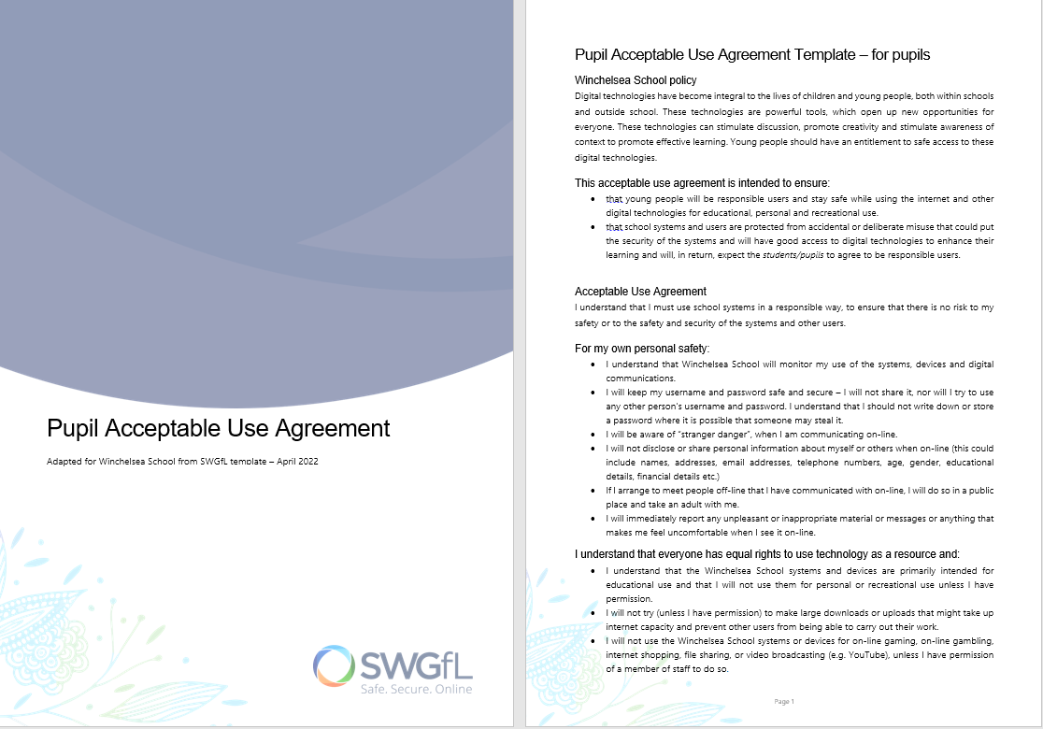
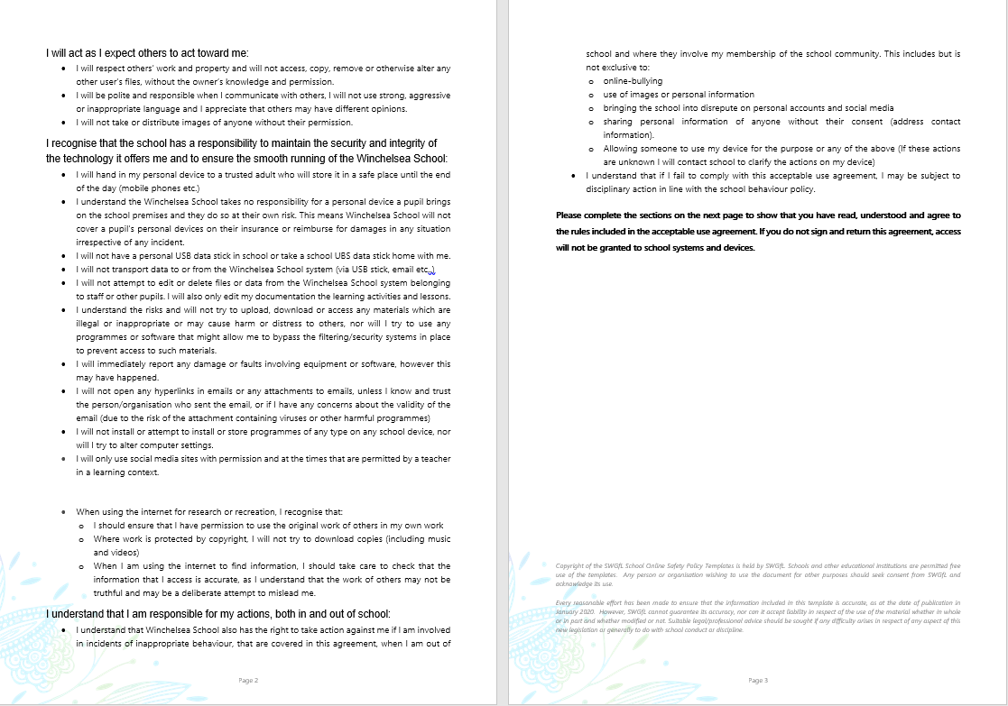

Appendix 2: acceptable use agreement (staff, governors, volunteers and visitors)

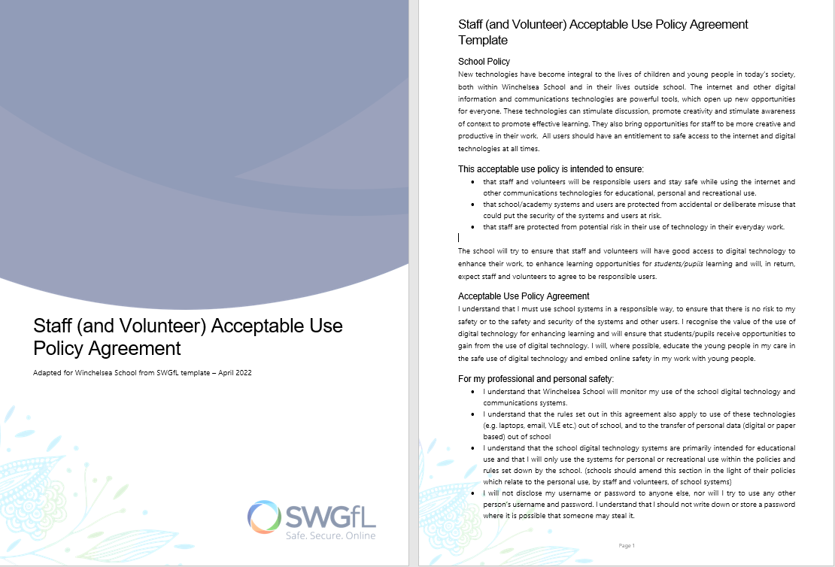

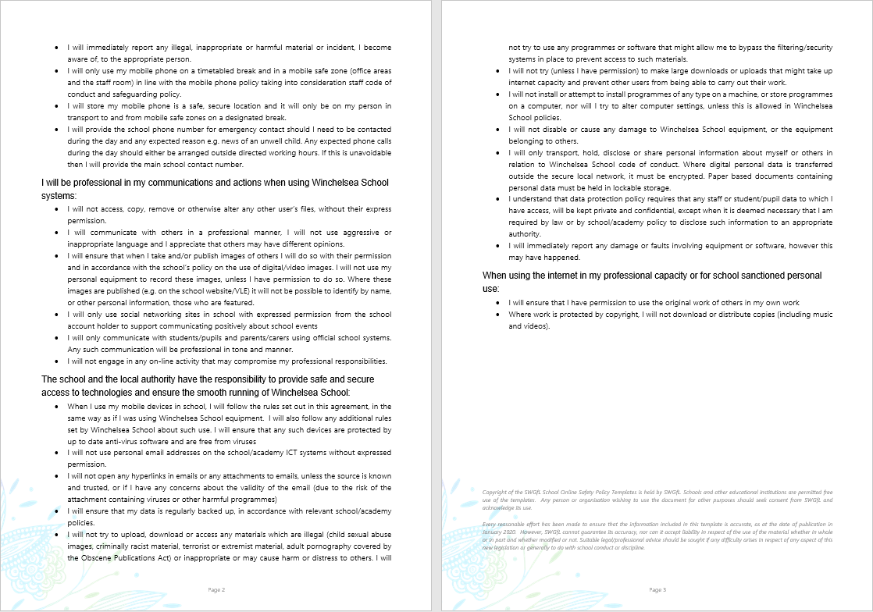

Appendix 3: online safety training needs – self audit for staff
(To utilise September 2022)
online safety training needs audit
Name of staff member/volunteer: | Date:
Question | Yes/No (add comments if necessary)
Do you know the name of the person who has lead responsibility for online safety in school?
Are you aware of the ways pupils can abuse their peers online?
Do you know what you must do if a pupil approaches you with a concern or issue?
Are you familiar with the school’s acceptable use agreement for staff, volunteers, governors and visitors?
Are you familiar with the school’s acceptable use agreement for pupils and parents?
Do you regularly change your password for accessing the school’s ICT systems?
Are you familiar with the school’s approach to tackling cyber-bullying?
Are there any areas of online safety in which you would like training/further training?

Appendix 4: online safety incident report log - Example from CPOMS

Appendix 5: online safety curriculum statement overview – Adapted from Childnet.com (ES4 additional by TD)
Online Safety 1 – Introduction
ES1 is an introduction to Online Safety looking at being kind online, understanding personal information and who to share it with, looking at the basics of what is appropriate and inappropriate, who is safe and unsafe to talk to and asking for help from a trusted adult.
Area | Statements | Secure Understanding
Conduct | I know how to be kind online. | Answers linked to helping others and acting like an offline friend.  Asking if it is ok to take a picture or video of a friend (Consent).
Conduct | I can define cyber bullying. | Answers linked to being made to feel upset by an individual or group of children more than once.
Conduct | I know who to talk to if I'm being cyber bullied. | One or two familiar people such as friends, family or a trusted adult.
Content | I understand personal information and can give examples. | Any information about you. Name, age, location, address, school, likes, dislikes, hobbies, telephone number, email address etc...
Content | I know who I can share my personal information with. | People you know and trust such as friends and family. Don't share things online that you would not tell a stranger.
Content | I know who not to share my personal information with. | Answers linked to who you wouldn't tell the information to and to only tell a trusted adult.
Content | I know what people can find out my personal information. | Where you live, where you go to school, how to contact you etc...
Content | I know who to talk to if I am worried about online issues | One or two familiar people such as friends, family or a trusted adult.
Content | I can identify things that are appropriate/in-appropriate online. | Appropriate - Linked to playing, learning and exploring the internet.  Inappropriate - Things that scare you or things that you have been told not to go on by your adults.  How do you know - You have been told by an adult that it’s ok.
Contact | I know who it is safe/unsafe to talk to online. | Safe – family and friends  Unsafe – strangers
Contact | I know to talk to an adult if I'm contacted by a stranger. | Not talk to them and tell a trusted adult.

Online Safety 2 – Staying Safe
ES2 builds on the previous knowledge looking at how to act safely when sharing person information. If you are being bullied what to do, who can help. Introducing the reporting process, understanding age ratings, Who is safe to accept friends requests from.
Area | Statements | Secure Understanding
Conduct | I know it is my responsibility to look after my personal information. | Answers linked to the fact that they have a personal responsibility to look after themselves and others online.  Not sharing personal information unless it is with a trusted friend or adult (Giving consent).
Conduct | I know what can be done if I'm being cyber bullied. | They can block the user and report them to CEOP (Child Exploitation and Online Protection Command).
Conduct | I know the difference between talking on/offline. | Not being able to see the person they are talking to, not knowing who they are or trusting if they are who they say they are.  if it's a video, is there someone else there?
Content | I know what to do with my computer if I am being cyber bullied. | If being cyber bullied or stranger asks for information.  - Don't tell them.  - Put the screen down (don't turn off the computer.)  - Tell an adult.  - Report it (with help to CEOP).
Contact | I know that you can report online problems to CEOP. | To an adult you trust who can block the user and also CEOP (with help)
Content | I understand age rating on game/film websites. | Appropriate and inappropriate content can be identified by the child’s using and age restrictions guides PEGI (Pan European Games Information).
Content | I understand PEGI.
Content | I know not everything online is true and can give examples. | Everything is not true online – linked to fiction and edited pictures with obvious errors - aliens landing, other realistic fictional images
Contact | I understand that I shouldn't accept strangers as friends. | What do you call someone you haven’t met – stranger  What do you do if they request you as a friend - Reject them, don't reply, tell an adult and know not to pass on any information.  It's ok to say no, it's not rude.

Online Safety 3 – Actions, Consequences and Management
ES3 is linked to understanding the potential risks and dangers online including their consequence, independence in reporting. How their actions and post online can make others see them and what impact that can have on their futures. Introducing terms of illegal activities online. How to manage and block friends or comments and enable and disable feature setting such as comments online.
Area | Statements | Secure Understanding
Content  Contact | I can give examples of online dangers. | Answers linked to meeting strangers, being taken away, taken advantage of (possibly sexually), grooming, blackmail, lied to about what is right and wrong (Extremist recruitment). Personal information stolen linked to identity theft.
Conduct | I can complete a CEOP report. | Tell trusted adult and know how to complete forms on CEOP website (link on school website), understand how to block users in applications and social media.
Conduct | I understand the term digital footprint. | All the information posted online through social media (photos, comments, posts, opinions) is online and can be found through searches by other people.  Once it is out there then it can be very difficult to remove – Always think before posting.
Conduct | I understand the importance of my digital footprint. | A future employer, college may search for them and see something from their past and judge them on it. Be careful as once online it can be copied and last forever on the internet. People may copy what they have put up or pictures and use them for themselves.  You can impact other people’s digital footprint by tagging them in your posts or posting pictures / videos other them – get their consent (Consent)
Conduct | I can give examples of illegal activities online. | Piracy, illegal downloading, identity theft, publishing sexual images or videos of children under 18.
Content | I understand strong passwords are to protect my personal information. | Using strong passwords and verification systems.
Content | I know my information can be hacked or stolen illegally. | Hacking accounts, identity theft, stealing account details, fraud.

Content | I understand the ages for various social media sites. | Things appropriate to their age such as social media (Common sense media website).
Content | I know the purpose of 'terms and conditions'. | This outlines what data an app or program can download from your phone or device such as pictures, access to friends lists, and contacts, what apps you use, when and how long you are on your phone to sell to marketing agencies.  If an app is free then they are likely to be harvesting information from you to make their money
Content | I know how to find out if what is online is true (Critical Thinking). | Can you trust the website (is it official e.g. BBC, FA, other official websites).  When you search for it, can you find it from another source.
Contact | I know how to manage online friends. | - Only add people I have met and trust.  - Share my contacts with trusted adults.  - Delete others who upset you.  - Communicate with trusted adults on areas you are concerned about.  - Blocking users you don’t want  - Adjusting settings to allow or disable features such as comments.  - Report inappropriate behaviour correctly CEOP.

Online Safety 4 – Online Risks and Recognition (Commerce)
ES4 - critical thinking is key to the analysis of information and discussion.
Area | Statements. | Secure understanding.
Content | I understand the risks of sharing friends information without their consent. | - People they don’t know can contact them.  - There is probably a reason they don’t have access to them that you don’t know or might not be aware of.  - Check with them first!
Commerce | I know a range of dangers online linked to contact. | - Children criminal exploitation.  - Children Sexual Exploitation.  - Modern slavery.  - Extremism / Radicalisation / Terrorism..  - Dark Web – critical thinking, who pays for it?
Conduct | I can outline a range of illegal activity online and explain the dangers. | - Cyber crime.  - Peer/ Peer Sexual Violence.  - Sharing of nude images (YPSi).  - Up-skirting.  - Dark Web – critical thinking, who pays for it?
Contact | I understand who can help me if I get in trouble online. | It will be hard but it can stop if you talk.  - Telling a trusted adult.  - CEOP report.  - Telephone support – childline.  - Blocking.  - Reporting to apps / websites.  - Report remove.  - Report harmful content.
Content | I can identify ways in which I can report inappropriate content online I see or which contains my information.
Contact | I know a how dangers online can affect my personal safety. | - Life impact from these activities.
Contact | I can identify signs someone is trying to groom or exploit me. | - Commerce dangers and illegal activity outlines.  - Critical Thinking.
Contact | I can identify signs that someone is trying to recruit or manipulate me.

Commerce | I understand the law and consequences linked to illegal online activity. | - Commerce dangers and illegal activity outlines.
Contact | I can understand how to identify deceptive contact online | - Inappropriate advertising.  - Financial scam (Clickbaiting / Identity Theft / Get rich quick /Smishing / Catfishing / Purchasing scams / Quizzes and competitions Phishing) – advice below.
Contact | I can understand how to stay safe from deceptive contact online. | - Tactics to stay safe.
Commerce | I can identify the impact excessive gaming can have on me, my health and wellbeing. | - Mental health and wellbeing.  - Sleep.  - Mood swings anxiety.
Commerce | I understand the law on gambling. | - Minimum age - 18 to gamble on and offline.
Commerce | I understand a variety of ways I can be misled on line. | - Inappropriate advertising, phishing and/or financial scam.
Commerce | I can provide strategies to control gaming habits and know where to get help to game safely. | - Times.  - Location of console.  - Who you game with.
Commerce | I can identify different clues to spot misleading information and stay safe. | - Critical thinking - where is it from – what do they want – does it sound too good to be true.
Commerce | I understand the risk of gambling and know how to stay safe | - Gamble aware.

Appendix 6: SMSC Curriculum links
Spiritual Development | Moral Development
- Develop and reflect upon personal beliefs and values.  - Experiencing Awe, wonder and fascination.  - Exploring the Values and beliefs of others.  - Willingness to reflect on their experiences.  - Using imagination and creativity in learning. | - Developing and expressing personal views or values.  - Recognising right and wrong and applying it.  - Understanding the consequences of actions.  - Investigating moral values and ethical issues (understanding others viewpoints).  - Recognise legal boundaries and respect the civil and criminal law of England.
Social Development | Cultural Development
- Developing personal qualities and using social skills, including those from different backgrounds and ethnicities to their own.  - Participating, cooperating in community life and resolving conflicts.  - Understanding how communities and societies function to develop mutual respect towards those that are different.  - Develop and demonstrate skills and attitudes that will allow them to participate and contribute to life in modern Britain. | - Exploring, understanding and respecting diversity across the school and the wider community.  - Participating and responding to cultural activities (Art, Music, Sport.)  - Knowledge of the democratic process and its role in shaping our lives and developing modern Britain.  - Understanding and appreciating personal influences that shaped their own heritage and that of others.  - Exploring, understanding and respecting different faiths and cultural diversity, both locally, nationally and globally.

Appendix 6: Winchelsea Top 10 Online Safety tips
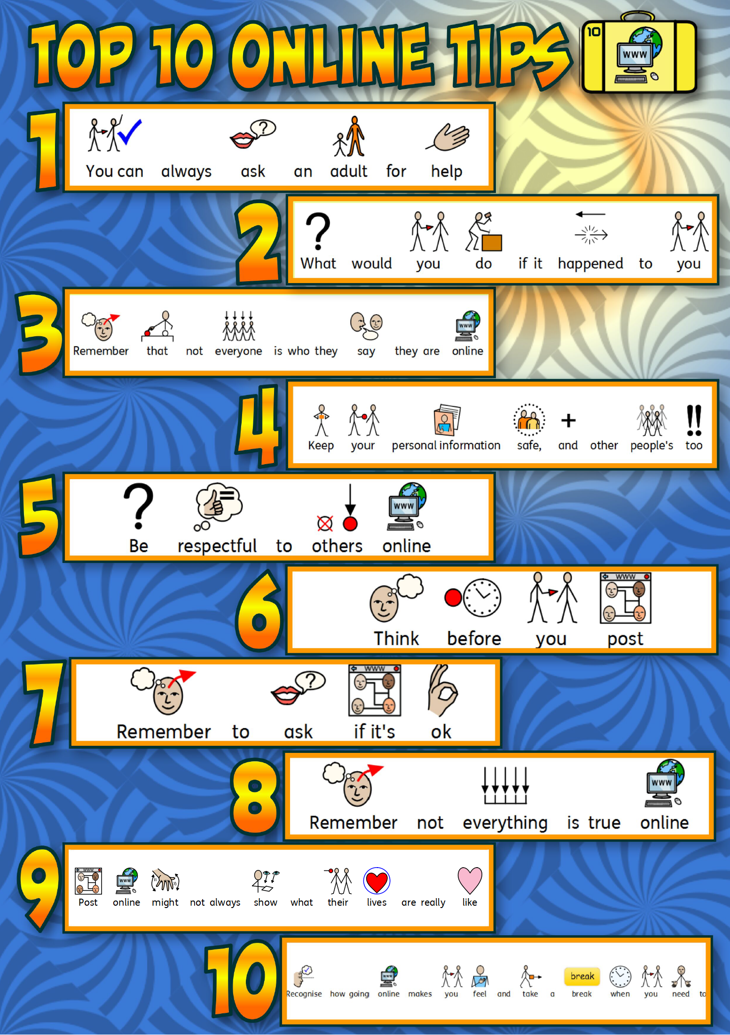

Appendix 7: online safety resources list including but not exclusive to:

 |  |  | 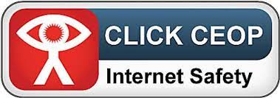 | 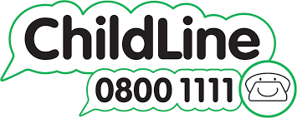
saferinternet.org.uk | nspcc.org.uk/keeping-children-safe/onlinOnline Safety/ | swgfl.org.uk | ceop.police.uk/Safety-Centre/ | childline.org.uk
 |  |   Tim*proevo8 |  | 
childnet.com | Azoomee - Search it up | projectevolve.co.uk | Internet Watch Foundation  https://www.iwf.org.uk/ | Vodafone – digital parenting
 | 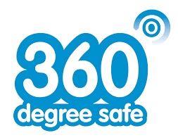 |  | 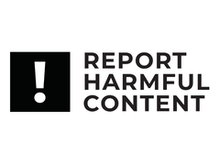 | Additional resource links can be found in KCSIE 2021 Annex D
 | 360safe.org.uk | Report remove – (Childnet) | reportharmfulcontent.com | Additional resource links can be found in KCSIE 2021 Annex D

